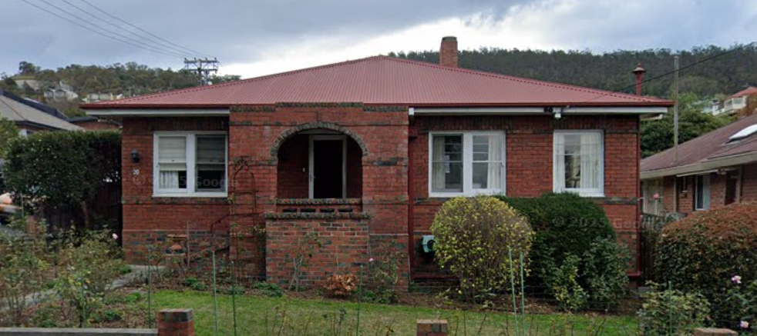

Prepared for: Regina Vietz

Project: Bathroom Renovation

Address: 20 Mellifont St, West Hobart

Prepared by: Action Builders Pty Ltd

Address: 116a Sandy Bay Road, Sandy Bay

Document Date: February 2026

Reference Documents:

Architectural Drawings – not required
Supplied by
Dated 25/11/25
Page Numbers
BAL Rating TBA

Structural Drawings – not required
Plans supplied by
Dated
Page Numbers

Civil Drawings – not required
Supplied by
Dated
Page Numbers

Hydraulic Drawings – not required
Supplied by
Dated
Page Numbers

Planning Permit – not required
Titles
Permit Number
Issue Date

Plumbing Permit – not required
Council
Permit Number
Issue Date

Certificate of Likely Compliance – not required
Issued by
Permit Number
Issue Date

Cost Centre Scope – Detailed Preliminary Draft

Project: 20 Mellifont – Full bathroom and WC renovation
Assumed Finish Level: Medium
Project Brief:
- The intent of the project is to create a functional bathroom and WC for Regina at a modest price point
- There is also remedial work that needs to be undertaken to fix deteriorating areas on adjacent walls to the existing shower enclosure in the Galley and the Kitchen caused by a water leak in the shower area.
- We will be stripping the WC and bathroom fixings completely along with the tiles and bath (including brick hob) to bring the room to a good starting point. The existing doors and furniture will all be staying in situ and we will leave as much of the existing plaster in place as possible. IE: the demolition work will only need to be done to the minimal extent to remove the bath and create the new shower area. A new vanity and toilet suite will go back in the existing positions.
- We will be creating a hob for the shower base to avoid scabbling and cutting too much concrete – it will be an enclosed shower, so no need for floor waste
- We want to do the minimal amount of work possible in the shortest timeframe possible as Regina does not have another bathroom in the house.
- SECURITY of the home is important to Regina – this will be a high priority for us to ensure we know who is on site, when they are there and that the house is kept secure at all times we are custodians of it

Building Materials – Fit Out

Overview:
- Covers supply of a new doorstop for the bathroom door only
Scope items:
- Supply of one internal door stop – Adoored Satin Chrome Trumpet Magnetic Door Stop #4133223

Building Materials – Wall Frames

Overview:
- Covers new wall framing to create a shower ledge and floor hob for shower base so we can screed into it
Assumptions:
- Shelf will be apx 2m long x 1100mm high using 90mm timber and 6mm Villaboard on top & face
Scope items:
- Supply and delivery of timber wall framing to create a shower wall ledge – apx 1.1m high x 2m long using 90mm framing
- Supply and delivery of one sheet of JH Villboard lining – 2400x1200x6mm
- Supply and delivery of one length of JH Axent Trim – 45x38mm (to create floor hob)
- Supply and delivery of timber wall framing fixings – including nails, screws, bolts, glue, connectors etc

Carpentry

Overview:
- Covers carpentry works associated with the renovation
Assumptions:

Scope items:
- Install timber wall framing for shower shelf wall – apx 2m long x 1100mm high – construct with 5^ fall to top shelf so water runs off shelf
- Line new timber wall with 6mm villaboard
- Install Axent trim to floor (polyurethane & screw fix) to create bath hob (ie an area to screed into) – seal with polyurethane sealant on both sides of the floor
- Complete internal bathroom fit out – Includes:
  - Install vanity unit – floor mounted
  - Install toilet roll holder
  - Install door stop
  - Install robe hooks
  - Install towel ring
  - (NOTE: into brick walls & concrete floor)

Cleaning

Overview:
- Covers cleaning associated with renovated areas and affected spaces. This includes additional cleaning due to works within an occupied or existing home. Final clean prepares the space for use.
Scope items:
- Clean IXL Tastic cover in Water Closet
- Internal clean and sanitisation of all internal surfaces in the bathroom and WC to a “ready use” standard prior to completion
- Also includes cleaning of any area of the existing house that are affected by the works – eg: outside areas, kitchen, hallway and galley

Demolition – labour & waste disposal

Overview:
- Covers demolition required to facilitate alterations to bathroom and WC. Allowances consider access constraints and waste handling. Care is taken to minimise disruption.
Assumptions:
- That the existing glass bricks will remain in place
- Existing mirror to remain in place
- That existing internal doors & furniture are all staying in place
- That existing plaster walls and ceiling will remain in place wherever possible
- That there will be the minimum of disruption or demolition work as possible
- The locations of TR holders, switches, GPO’s, taps, pipes etc will all remain as closely as possible to their existing locations
Scope items:
- Site protection – access through rear entry
- Site protection – protect carpet adjacent to the bathroom door
- Site protection – protect kitchen and galley areas while wall preparation and painting are in progress
- Labour for demolition and disposal of existing shower screens and base
- Labour for demolition and disposal of existing wall and floor tiles throughout bathroom & WC
- Labour for demolition and disposal of bathtub and brick bath hob (note: bath tub is cast iron)
- Labour for demolition and disposal of existing vanity unit and fittings
- Labour for demolition and disposal of existing toilet suite and toilet roll holder
- Bin hire and/or disposal fees for all removed items during demolition

Electrical

Overview:
- Covers minimal Electrical work required.
Assumptions:
- that all existing lights, switches and fans stay in place
Scope items:
- Isolate existing wall GPO in bathroom to allow for safe demolition works
- Isolate existing skirting mounted GPO in kitchen to all for safe remedial work & painting to skirting
- Reinstate existing GPO’s at completion of project & test
- Purchase new cover for IXL Tastic and install

Painting & Rendering

Overview:
- Covers painting and rendering to new and affected existing areas. Works include blending with existing finishes. Allowances reflect surface preparation requirements.
Assumptions:
- That kitchen wall can be prepared by a painter and that a plasterer is not required for this work
- That galley wall does not require repointing – painter to prepare only
Scope items:
- Painting - Internal
  - Ceiling height = apx 3.0m
  - Prepare and paint ceiling of Bathroom and WC
  - Prepare and paint all walls of Bathroom and WC – including filling and sanding of hairline plaster cracks prior to coating
  - Prepare and paint window reveals, architraves and skirtings in the WC
  - Prepare and paint doors and door jambs of Bathroom and WC (both sides)
- Painting – specialised
  - Prepare and paint existing brick wall in Galley adjacent to current shower enclosure – only paint lower section to blend in as well as possible and check if owner is happy with the finish before we commit to painting the whole wall – apx patch area = 1100mm wide x 600mm high – client has the colour name to match
  - 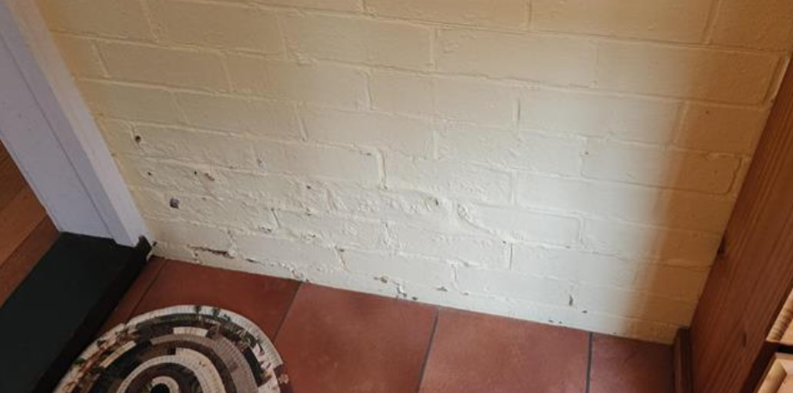
  - Prepare and paint existing solid plaster wall in kitchen adjacent to current shower enclosure – includes cleaning up existing wall where water damage has occurred prior to painting to match in with existing as closely as possible – allow to paint complete wall to the LHS of the damage to the corner and then feather out above doorway or similar… Wall apx 3m wide x 2.7m high
  - 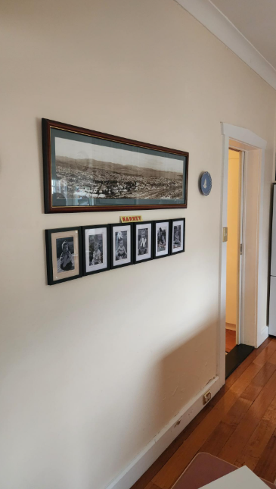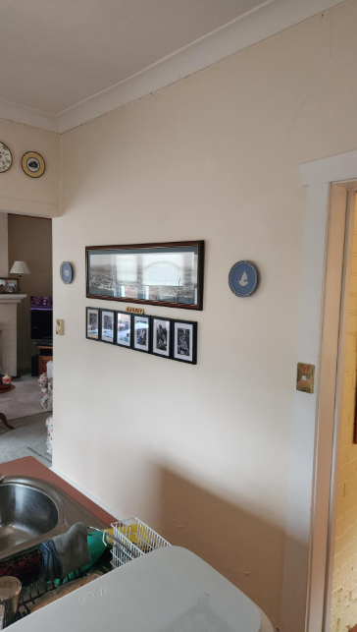
Feather out here above door if possible
  - Prepare and paint existing timber skirting to kitchen wall adjacent to current shower enclosure – apx 3m long

Plumbing & Drainage

Overview:
- Covers new and modified plumbing and drainage for the bathroom & WC. Includes disconnection of all existing plumbing items and then installation of floor drain for shower, tapware for shower, waste for vanity, tapware for vanity and new toilet suite installation.

Assumptions:
- That we can connect to existing water and drainage services and there is no need to upgrade either of them.
- That we will not need to install a pressure limiting valve for the incoming water line – price if required - $
- That we will not need to install a tempering valve to the existing HWC – price if required - $
Scope items:
- Water
  - Disconnect existing vanity unit & tapware, bath & tapware, shower and tapware, and toilet suite to allow for safe demolition work inc removal of existing toilet suite
  - Decommission existing bath taps as not being reused
  - Rough in water pipes for shower mixer to new location (NOTE: brick walls)
  - Fit off all newly supplied fixtures – inc toilet suite, shower mixer and shower head and vanity tapware
  - Complete brick cutting to chase new water lines in wall as required
  - Install filler to brick walls to hold new water pipes in place suitably
- Sewer
  - Connect all sewer to existing connection points on site
  - Complete concrete cutting to chase new drains in shower floor as required
  - Install new concrete to floor to hold new drains in place suitably
  - Excavate for drains – including removal and disposal of spoil, supply and placement of gravels and backfilling if required

Plumbing & Sanitary Fittings

Overview:
- Covers new sanitary fittings installed within renovated areas. This may include replacement of existing fixtures. Allowances reflect upgraded finishes. Integration with existing services is considered.
Assumptions:

Scope items:
- Supply and delivery of fittings & fixtures for bathroom
  - Shower mixer – to be fitted in shower ledge wall – Empire Slim Wall Mixer – Round Plate - Chrome
  - Shower head – to be fitted roughly where existing one is – Empire Slim Rail Shower - Chrome
  - Vanity unit – to be installed in place of existing – Nevada Plus – 900mm, Alpha Ceramic Top, Floor mounted
  - Vanity plug & waste – to suit basin – Misha Pop Up – 32mm Chrome
  - Vanity tapware – to be basin mounted (not wall mounted) – Lina Basin Mixer - Chrome
  - Towel Ring – Misha Towel Ring - Chrome
  - Robe Hooks – Lina Robe Hooks - Chrome
  - Shower floor waste – suggest tile insert – square grate
- Supply and delivery of fittings & fixtures for WC
  - Toilet – over height seat – Vera BTW Uni80-180 Extra High Tornado Toilet Suite
  - Toilet Roll Holder – to replace existing – Lina Toilet Roll Holder - Chrome

Exclusions:
- No allowance to supply and/or install a new wall mirror – existing to remain
- No allowance to supply and/or install a new towel rail – existing to remain

Site Costs

Overview:
- Covers site-related costs specific to renovation works. This may include protection of existing structures and restricted access. Allowances reflect additional care required. These costs support safe construction activity.
Assumptions:

Scope items:
- Site signage – company & safety signage to be installed at entry and around site
- Security signage to be installed at entry and around site
- Waste disposal – includes bin hire and disposal fees throughout project for trade waste
- Protective materials dust covers etc ..

Tiling – All Inclusive

Overview:
- Includes supply and installation of wall and floor tiles in the bathroom and WC. This covers adhesives, grout, trims, and labour. Allowances reflect medium–high quality tiles and finishes.
Assumptions:
- 2.1m high wall tiles in shower enclosure only
- Skirting tiles to remainder of the bathroom and WC (to match the floor tiles – cut to 150mm high) except eastern elevation which will align with glass bricks and tiled shelf height from FFL
- Splashback tiles behind the bathroom vanity, between vanity unit and glass bricks
- Tile trim to all exposed and cut edges
Scope items:
- Supply and install tiles to bathroom and WC
  - Supply and delivery of floor tiles - OmniStone Beige CB-Porc Microtec Text Rect - 600x600mm
  - Supply and delivery of wall tiles - OmniStone Beige CB-Porc Silk Rect 600x600mm
  - Supply and delivery of feature tiles - Imagination Eucalypt Satin 75x300mm
  - Install floor self-levelling compound prior to start of tiling to WC
  - Install screed to top of ledge to create fall
  - Install screed to shower base floor to create fall to waste
  - Install screed to other areas to level/plumb before tiling (eg: existing shower walls)
  - Cut and lay floor tiles to bathroom and WC
  - Cut and lay tiles to shower base
  - Cut and lay floor tiles for skirtings (150mm high to match floor tiles) to WC
  - Cut and lay wall tiles to shower enclosure – allow for 2.1m high in shower enclosure to match shower screen heights
  - Cut and lay wall tiles to vanity splashback
  - Cut and lay wall tiles to shower ledge
  - Supply and install tile trim to exposed and cut tile edges
  - Supply and place standard grout to tiles
  - Supply and place sealant to tiles at all junctions to be done by tiler

Trade Labouring

Overview:
- Covers labour support specific to renovation activities. This included demolition assistance and protection works.
Scope items:
- Remove and thoroughly clean existing skylight cover in ceiling and place back in position
- Place floor and dust coverings as required to areas affected by tradespeople and/or the works in the galley, hallway, entry and kitchen
- Remove and dispose of paint to galley wall where brickwork is water affected to expose bricks and mortar for repair work and then repainting

Waterproofing

Overview:
- Covers waterproofing to the bathroom and WC. Entire floor of the bathroom and WC will be waterproofed, and the walls of the shower enclosure will be waterproofed. All waterproofing will be completed to the standard required for compliance with the current NCC.
Scope items:
- Apply internal waterproofing to bathroom to comply with NCC
- Apply internal waterproofing to WC to comply with NCC

Exclusions
The following items will not be allowed for in our initial pricing model:

- any fees incurred with Tas Networks, Tas Gas, Tas Water, NBN, Aurora or similar
- any design fees (architect, designer, engineer, hydraulic or similar)
- any council fees
- any building surveyor or specialist consultant fees unless listed in scope
- upgrading of existing plumbing and or drainage – it is assumed that we can connect to existing plumbing
- any new electrical works – allowance is to isolate and then refit existing only
- supply and/or installation of new glass shower screens
- NOTE: any items not listed in this scope are considered exclusions

NOTES:

REQUIRED DOCUMENTS/FORMS PRIOR TO START:
- Internally produced set of dimension and layout plans
- Tile lay plans

SELECTION ITEMS OUTSTANDING:
- List items here that the clients still need to select
  - Shower screens
  - Paint colours

CLARIFICATION REQUIRED ON ITEMS
- SE to confirm that all internal walls are brick to work out the extent of plastering
  - May need to allow a provisional sum for this if can’t be worked out
  - Regina happy to tile over – no need for plaster patch work
- SE to check extent of painting required to Galley wall to match into existing
  - Regina happy to paint patch only for now and see what it looks like before painting the whole wall
- SE to check extent of painting required to Kitchen wall & skirting to match into existing
  - Added to scope – apx 3m x 2.7h
- SE to confirm exhaust fan ducting options
  - Regina happy with existing fan suction – no need to install another one
- SE to confirm shower screens & mirror – Regina’s son to do?
  - Anthony to do – fixed screen with swinging door – exclude from AB scope
- SE to confirm access arrangements with Regina
- SE to confirm work schedule once scope is finalised
- EL to confirm all selections
  - Completed

YOUR INVESTMENT:

